REGNO:1518102062

DATE:13.10.2020

EXNO:3

Aim:

Write a Python program to remove and print every second number from a list of numbers until the list becomes empty.

Program:

def removeThirdNumber(lst):

lst1=[]

pos=1

s=0

for i in range(0,len(lst)):

s=(pos+s)%len(lst)

e1=lst.pop(s)

lst1.append(e1)

return lst1

n=int(input())

int_list=[]

for i in range(0,n):

e=int(input())

int_list.append(e)

p=removeThirdNumber(int_list)

print(p)

Link: [http://103.53.53.18/mod/vpl/forms/edit.php?id=231&userid=1680#](http://103.53.53.18/mod/vpl/forms/edit.php?id=231&userid=1680)

Output:

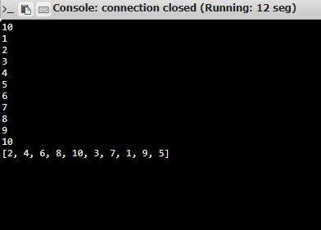

Result:

Thus the Python program is written to print every second number from a list of numbers until the list becomes empty.

And the Output is Verified